**Property Site Visit Photo**

1. **Property Information:**

|  |  |  |  |  |  |  |  |  |  |  |
| --- | --- | --- | --- | --- | --- | --- | --- | --- | --- | --- |
| **Property Information** | | | | | | | | | | |
| Property Type | : A parcel of land cum with a single warehouse | | | Land Area | | | : 114 sqm | | | |
| Property Address | : Ph. 1, SK. Boeung Kak 1, Kh. Toul Kork, PP Ph. 1, SK. Boeung Kak 1, Kh. Toul Kork, PP | | | Estimated Building Area | | | : 104 sqm | | | |
| Formal VR | : N/A | | | Date | | | : 05-04-19 | | | |
| **Security Value** | **Valuation Report** | | | **Indicative Value** | | | | | | |
| Land Value | : N/A | | | : USD399,000 | | | | | | |
| Building Value | : N/A | | | : USD5,000 | | | | | | |
| **OMV** | **: N/A** | | | **: USD404,000** | | | | | | |
| Valuer(s) | : N/A | | | **ARC** | | | | | | |
| **Security Value** | **: N/A** | | | **FSV** | | | | **: N/A** | | |
| **Existing Insurance** | [ ] Yes | [ ✓ ] No | **Insurer** | **: N/A** | | | | | | |
| **Encumbrance** | [ ] Yes | [ ✓ ] No | **Bank Name** | **: N/A** | | | | | **Limit: N/A** | |
| **Property Conditions and Adverse Impacts on Market Value** | | | | | | | | | | |
| Occupancy rate of neighboring property | | | | | [ ] Poor | [ ] Fair | | | | [ ✓] Good |
| Demand for sale/rent | | | | | [ ] Poor | [ ] Fair | | | | [ ✓] Good |
| Incidence of crime on vicinity | | | | | [ ✓] Low | [ ] Average | | | | [ ] High |
| Road accessibility to the property over 6m | | | | | [ ✓] Yes | [ ] No | | | |  |
| Is the property located in flood area | | | | | [ ] Yes | [ ✓] No | | | |  |
| Is the property located near loathsome facilities (ref: page 18 of CPG) | | | | | [ ] Yes | [ ✓] No | | | |  |
| The property is found to be in good state of repair | | | | | [ ✓] Yes | [ ] No | | | |  |
| *If No, please comment:* | | | | |  |  | | | |  |
| **Brief on the property and surrounding area** | | | | | | | | | | |
| Property located along Street No. 355, Phum 1, Sangkat Boeung Kak 1, Khan Toul Kork, Phnom Penh and classified as a commercial area of Phnom Penh City (LTV: up to 80%) where it is near Toul Kork Antenna, about 300 meters and 500 meters far away from TK Avenue and Toul Sangke Market respectively. So, it is considered as a good location for business operation as well as for rent- Office Space.  Presently, the properties are surrounded by many business activities and residence such as Banks/MFIs, Markets, Schools, Shophouses, Camko City, Borey New World, Borey Peng Hout, Borey Vimean Phnom Penh, and Borey Toul Sangke, etc. | | | | | | | | | | |

1. 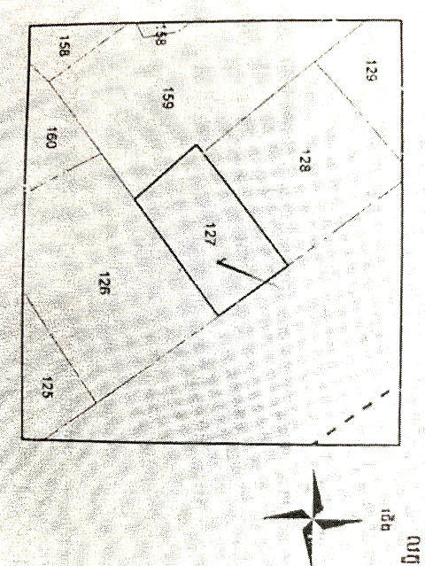**Land Shape:**
2. 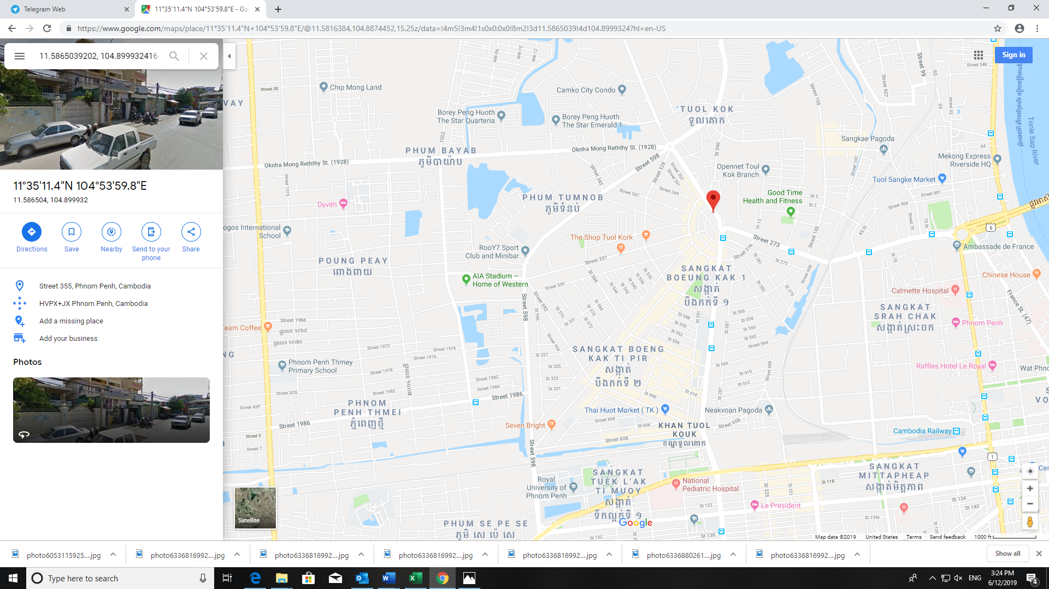**Location:**

**Toul Sangke Market**

**Subject Property**

**Toul Kork Antenna**

**Toul Kork Market**

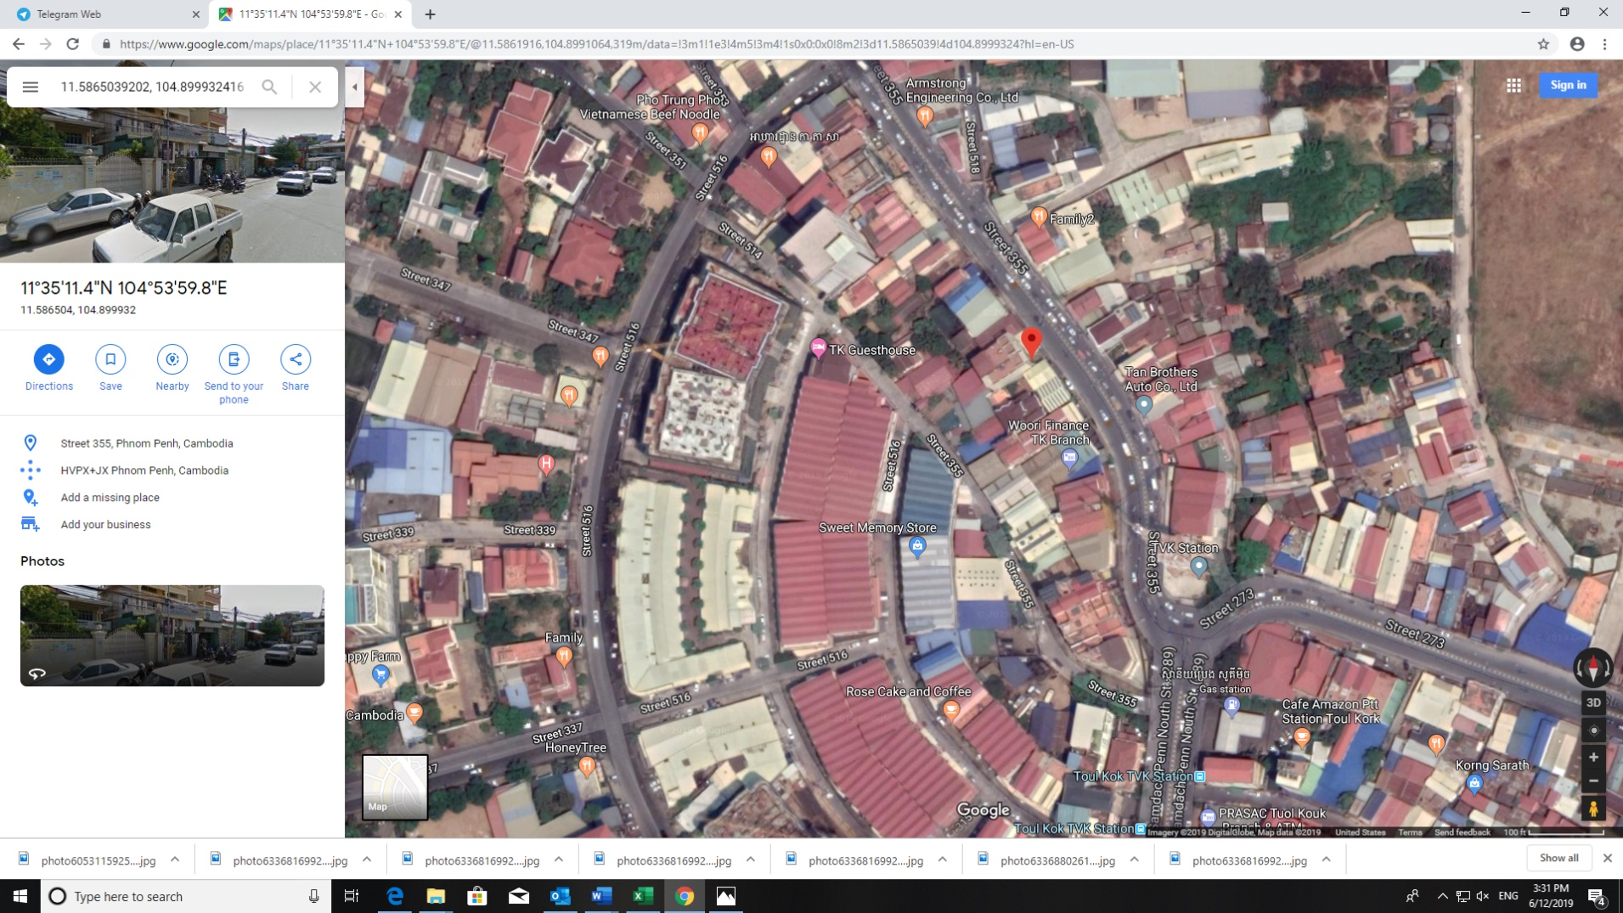

**Subject Property**

**Toul Kork Antenna**

**Subject Property**

1. **Property Photo:** (Collateral)

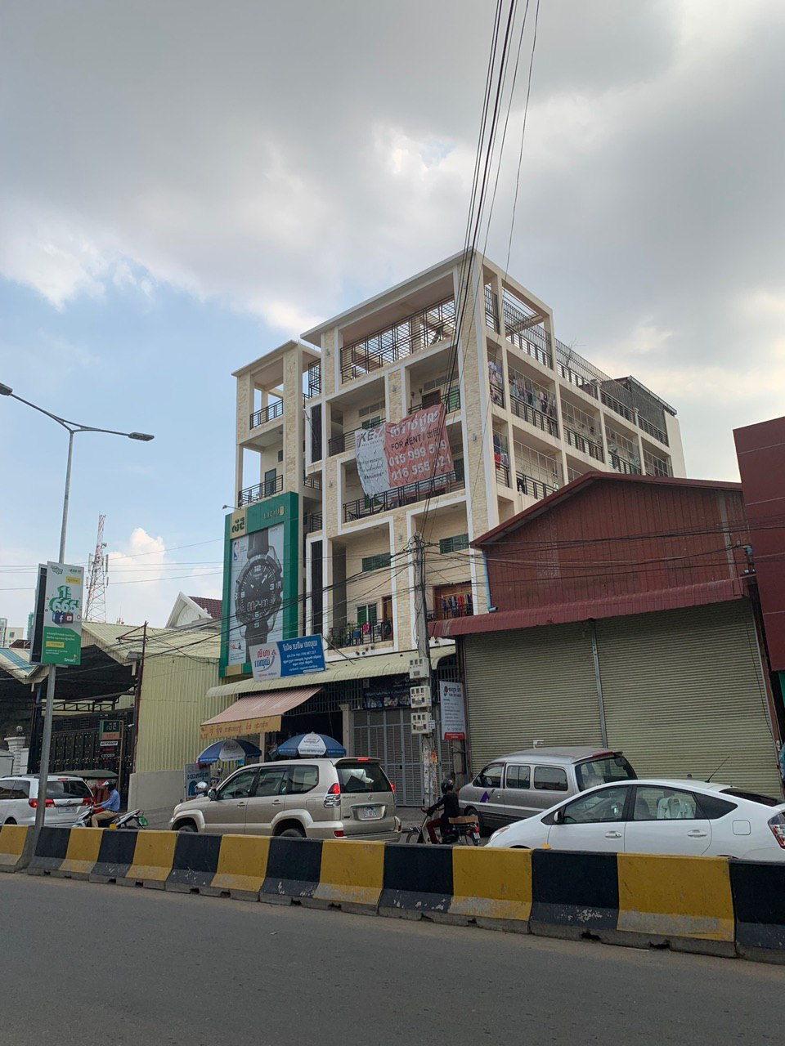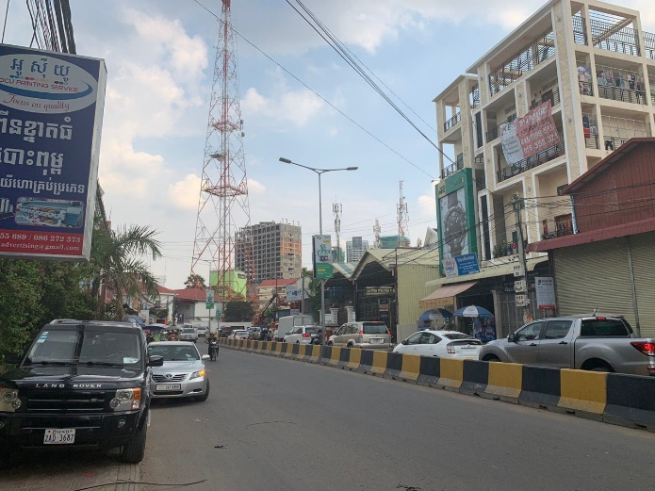

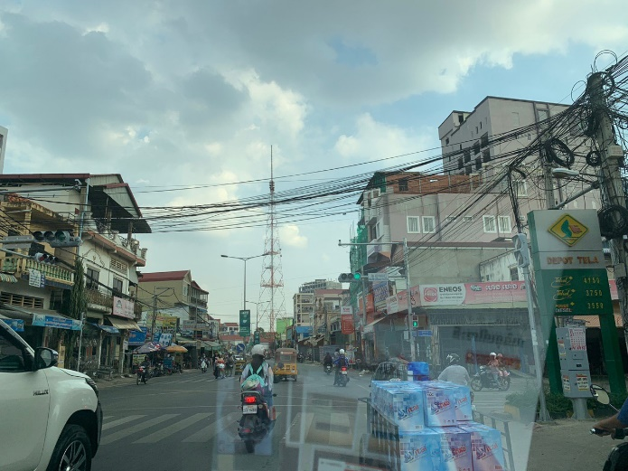

|  |  |
| --- | --- |
| Prepared by | Reviewed by |
| Mr. Sok Ratanak  Manager, Credit Analyst  Date: | Mr. Chiv Hak  Head, Business Development  Date: |